**Why NoSQL? Understanding Its Role in Today’s Data Systems**

**BY- GETSY JACINTH**

Data is everywhere in today’s world from social media posts to online purchases to IoT devices sending real-time updates. To manage and make sense of all this data, databases play a central role. A database is essentially an organized collection of information that can be easily accessed, managed, and updated.

For a long time, **Relational Databases** like MySQL, PostgreSQL, and Oracle were the industry standard. These databases store data in rows and columns, strictly following a predefined structure known as a schema. While this structure works well for traditional business applications, it struggles with today’s rapidly growing and changing types of data such as images, videos, social media feeds, or IoT sensor data.

That’s where **NoSQL databases** come in. “NoSQL” stands for “Not Only SQL”, meaning these databases don't rely solely on the rigid structure of SQL. NoSQL databases like MongoDB were designed to handle unstructured, semi-structured, and rapidly evolving data formats, offering flexibility and scalability that traditional SQL databases often lack.

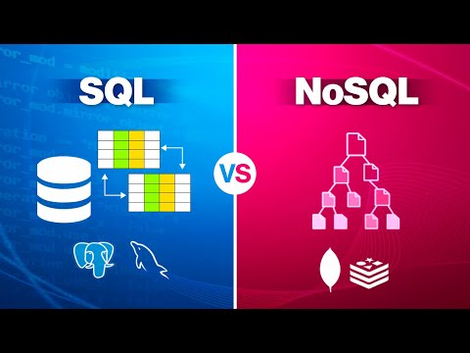

**Why NoSQL?**

In today’s world, applications are evolving faster than ever from large-scale e-commerce platforms to social media, IoT devices, and real-time analytics systems. These modern use cases require databases that are flexible, scalable, and capable of handling large volumes of complex data. That’s where NoSQL databases step in.

**Flexibility with Unstructured Data**

Unlike relational databases that enforce strict schemas, NoSQL databases like MongoDB allow for schema-less storage. This means:

* You can store varied data formats (JSON, BSON, etc.).
* Fields can differ between documents in the same collection.
* Applications can evolve quickly without worrying about database migrations.

*Example*: An e-commerce site where different products have different specifications storing all that in a single SQL table would be inefficient and cumbersome.

Types of NoSQL Databases:

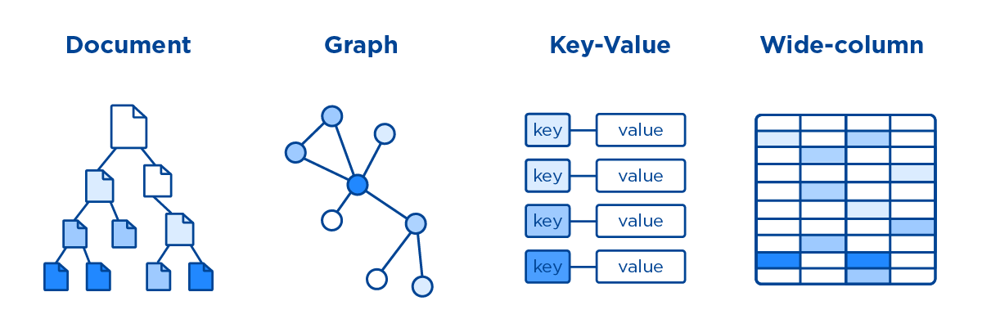

**Horizontal Scalability**

Traditional SQL databases typically scale vertically (adding more power to a single server). NoSQL databases are designed for horizontal scaling:

* Data can be distributed across multiple servers.
* Easy to handle growing datasets and high traffic.
* Supports sharding: breaking data into smaller chunks across different machines.

Cloud-native apps and globally distributed services require scaling beyond

a single machine.

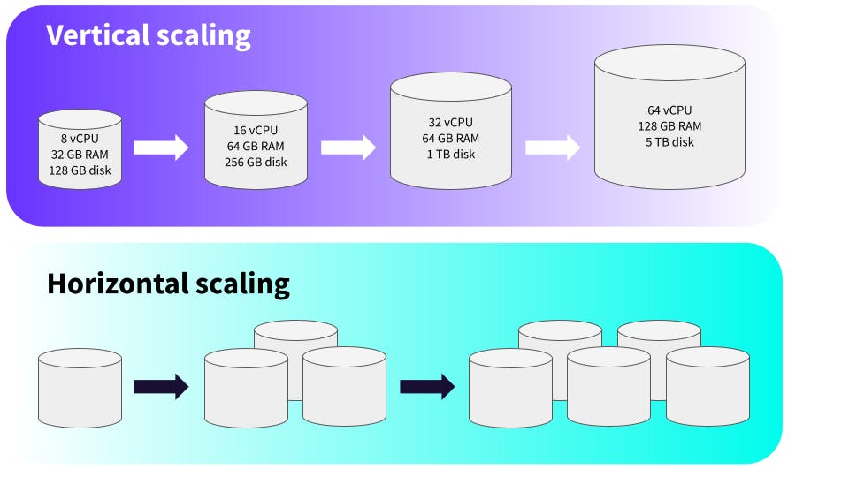

**High Performance and Speed**

NoSQL databases are optimized for:

* Fast read and write operations.
* Handling large volumes of simultaneous users.
* Storing massive datasets without performance bottlenecks.

This makes them ideal for real-time applications like chat apps, recommendation systems, and live analytics dashboards.

**Cloud and Big Data Friendly**

NoSQL fits naturally into modern cloud architectures and big data ecosystems:

* Integrates well with technologies like Apache Spark, Hadoop, and Kubernetes.
* Many NoSQL databases offer built-in cloud services (e.g., MongoDB Atlas).
* Supports JSON-like structures natively, making integration with RESTful APIs easier.

**What is MongoDB?**

MongoDB is a popular, document-oriented NoSQL database designed for modern application development. Unlike traditional relational databases that store data in rows and columns, MongoDB uses flexible, JSON-like documents to store information. This means developers can easily work with varied types of data without being restricted by rigid table structures.

**How MongoDB Stores Data**

At its core, MongoDB uses a data format called BSON (Binary JSON). BSON extends the JSON format by adding more data types, such as dates and binary data, while maintaining JSON’s easy-to-read structure. This makes MongoDB ideal for storing complex data structures in a simple and efficient way.

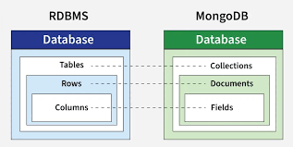

**Key Features of MongoDB**

* **No Fixed Schema:** Collections in MongoDB do not require a predefined schema. Documents within the same collection can have different fields, offering great flexibility.
* **High Availability:** MongoDB supports replication through replica sets, ensuring your data remains available even if some servers fail.
* **Horizontal Scaling via Sharding:** MongoDB can handle large amounts of data and high traffic by distributing data across multiple servers through sharding.
* **Built-in Aggregation Framework:** MongoDB provides powerful tools for transforming and analyzing data within the database, reducing the need for additional processing layers.

**Basic Concepts in MongoDB**

**Collections:**Groups of MongoDB documents, similar to tables in relational databases. However, collections do not enforce a strict schema, meaning different documents in the same collection can have different fields and structures.

**Documents:**The fundamental unit of data in MongoDB, equivalent to a row in SQL. Documents are written in BSON format, allowing nested structures and arrays. Each document has a unique _id field used as a primary key.

**Fields:**Key-value pairs within a document. Fields can contain simple values (like strings or numbers), arrays, or even nested documents.

**For example:**

{

"name": "Alice",

"email": "alice@example.com",

"age": 30

}

**Real-World Use Cases**

MongoDB is widely used in industries where flexibility and scalability are critical. Common scenarios include:

* **E-commerce:** Managing product catalogs that vary in structure.
* **Gaming:** Storing player profiles and dynamic game states.
* **Content Management Systems (CMS):** Handling various types of media content and metadata.

**SQL vs NoSQL (MongoDB) Comparison:**

Traditional SQL databases and modern NoSQL databases like MongoDB serve different needs. Below is a side-by-side comparison highlighting their core differences:

| **Feature** | **SQL Databases** | **MongoDB (NoSQL)** |
| --- | --- | --- |
| **Schema** | Fixed schema | Dynamic schema |
| **Scalability** | Vertical (scale-up) | Horizontal (scale-out via sharding) |
| **Data Type** | Structured (rows/columns) | Structured + Unstructured (JSON/BSON) |
| **Transactions** | Strong ACID compliance | Supports ACID (multi-document in newer versions) |
| **Query Language** | SQL | MongoDB Query Language (MQL) |

**Conclusion**

SQL databases remain essential for applications requiring strict structure, relational integrity, and complex transactions such as financial systems.  
However, as businesses increasingly deal with large volumes of semi-structured or unstructured data, NoSQL solutions like MongoDB have gained traction.

MongoDB offers:

* Flexible document-based storage with no rigid schema
* Easy horizontal scaling through sharding
* Built-in support for replication and high availability
* Developer-friendly query language designed for modern applications

In summary, SQL is ideal for structured, stable environments, while MongoDB is better suited for dynamic, large-scale, and evolving data systems. The choice depends on the project’s specific requirements regarding data structure, scalability, and performance needs.